Fichier chargé avec succès.
Dimensions : 400000 lignes, 12 colonnes
Taille mémoire : 228.95 Mo

=== 5 premières lignes ===
shipment_id product_id supplier_name origin_city destination_city \
0 SHIP0000000 PRD81347 Supplier_B Abuja Warri
1 SHIP0000001 PRD68757 Supplier_D Kano Jos
2 SHIP0000002 PRD34311 Supplier_E Lagos Port Harcourt
3 SHIP0000003 PRD14597 Supplier_D Lagos Ibadan
4 SHIP0000004 PRD98159 Supplier_D Lagos Enugu

ship_date expected_delivery_date actual_delivery_date quantity \
0 2024-03-23 2024-03-29 2024-03-27 828
1 2024-06-10 2024-06-21 2024-06-20 329
2 2024-10-15 2024-10-19 2024-10-18 203
3 2024-02-05 2024-02-19 2024-02-24 20
4 2024-03-31 2024-04-09 2024-04-14 465

shipping_cost_ngn logistics_company delivery_status
0 18379.93 DHL Nigeria delayed
1 91632.07 Fedex Nigeria delivered
2 77141.08 Ace Couriers delivered
3 69484.82 Kwik Delivery in_transit
4 47054.82 Kwik Delivery delivered

=== Types de données ===
shipment_id object
product_id object
supplier_name object
origin_city object
destination_city object
ship_date object
expected_delivery_date object
actual_delivery_date object
quantity int64
shipping_cost_ngn float64
logistics_company object
delivery_status object
dtype: object

=== Statistiques descriptives (numériques) ===
quantity shipping_cost_ngn
count 400000.000000 400000.000000
mean 504.906617 52547.524651
std 286.132913 27410.200740
min 10.000000 5000.290000
25% 257.000000 28810.150000
50% 505.000000 52634.390000
75% 753.000000 76271.502500
max 1000.000000 99999.530000

=== Statistiques descriptives (catégorielles) ===
shipment_id product_id supplier_name origin_city destination_city \
count 400000 400000 400000 400000 400000
unique 400000 88943 5 4 15
top SHIP0000000 PRD37465 Supplier_B Lagos Onitsha
freq 1 17 80273 100521 26970

ship_date expected_delivery_date actual_delivery_date \
count 400000 400000 400000
unique 301 314 321
top 2024-07-07 2024-06-17 2024-08-27
freq 1449 1416 1462

logistics_company delivery_status
count 400000 400000
unique 7 4
top Ace Couriers delivered
freq 57503 319577

=== Valeurs manquantes ===
Aucune valeur manquante détectée.

=== Lignes dupliquées ===
Nombre de doublons : 0

Variables numériques : ['quantity', 'shipping_cost_ngn']

Asymétrie de quantity : 0.000
Asymétrie de shipping_cost_ngn : -0.003

Variables catégorielles : ['shipment_id', 'product_id', 'supplier_name', 'origin_city', 'destination_city', 'ship_date', 'expected_delivery_date', 'actual_delivery_date', 'logistics_company', 'delivery_status']

=== Valeurs uniques de shipment_id : 400000 ===
shipment_id
SHIP0000000 1
SHIP0266650 1
SHIP0266672 1
SHIP0266671 1
SHIP0266670 1
SHIP0266669 1
SHIP0266668 1
SHIP0266667 1
SHIP0266666 1
SHIP0266665 1
Name: count, dtype: int64

=== Valeurs uniques de product_id : 88943 ===
product_id
PRD37465 17
PRD90451 16
PRD45268 15
PRD58425 14
PRD54214 14
PRD87617 14
PRD72576 14
PRD77650 14
PRD93976 14
PRD97171 14
Name: count, dtype: int64

=== Valeurs uniques de supplier_name : 5 ===
supplier_name
Supplier_B 80273
Supplier_D 80050
Supplier_E 80019
Supplier_C 79859
Supplier_A 79799
Name: count, dtype: int64

=== Valeurs uniques de origin_city : 4 ===
origin_city
Lagos 100521
Abuja 100228
Port Harcourt 99866
Kano 99385
Name: count, dtype: int64

=== Valeurs uniques de destination_city : 15 ===
destination_city
Onitsha 26970
Aba 26945
Calabar 26898
Port Harcourt 26832
Enugu 26814
Warri 26708
Ibadan 26679
Kano 26633
Benin City 26604
Abuja 26604
Name: count, dtype: int64

=== Valeurs uniques de ship_date : 301 ===
ship_date
2024-07-07 1449
2024-06-10 1424
2024-02-11 1413
2024-04-15 1410
2024-04-29 1406
2024-04-07 1405
2024-10-22 1404
2024-02-14 1401
2024-06-14 1400
2024-05-23 1395
Name: count, dtype: int64

=== Valeurs uniques de expected_delivery_date : 314 ===
expected_delivery_date
2024-06-17 1416
2024-10-24 1410
2024-09-04 1407
2024-08-05 1404
2024-06-13 1403
2024-05-31 1399
2024-07-17 1397
2024-05-01 1396
2024-07-02 1392
2024-04-23 1392
Name: count, dtype: int64

=== Valeurs uniques de actual_delivery_date : 321 ===
actual_delivery_date
2024-08-27 1462
2024-06-18 1446
2024-02-25 1421
2024-05-05 1412
2024-07-12 1406
2024-03-02 1404
2024-05-22 1404
2024-03-16 1402
2024-05-06 1400
2024-05-01 1396
Name: count, dtype: int64

=== Valeurs uniques de logistics_company : 7 ===
logistics_company
Ace Couriers 57503
Kwik Delivery 57406
Fedex Nigeria 57238
GIG Logistics 57166
Red Star Express 57078
DHL Nigeria 56960
Dispatch Riders 56649
Name: count, dtype: int64

=== Valeurs uniques de delivery_status : 4 ===
delivery_status
delivered 319577
in_transit 40054
delayed 32293
cancelled 8076
Name: count, dtype: int64

Colonnes supprimées : ['shipment_id', 'product_id']
Valeurs manquantes détectées :
delay_days 48130
dtype: int64

=== Détection des outliers (IQR) ===
quantity : 0 outliers (0.00%)
shipping_cost_ngn : 0 outliers (0.00%)

=== Transformations pour réduire l'asymétrie ===
Asymétrie initiale de shipping_cost_ngn : -0.003
Asymétrie après log : -0.995
Asymétrie initiale de quantity : 0.000
Asymétrie après log : -1.407

=== Aperçu après nettoyage ===
supplier_name origin_city destination_city ship_date \
0 Supplier_B Abuja Warri 2024-03-23
1 Supplier_D Kano Jos 2024-06-10
2 Supplier_E Lagos Port Harcourt 2024-10-15
3 Supplier_D Lagos Ibadan 2024-02-05
4 Supplier_D Lagos Enugu 2024-03-31

expected_delivery_date actual_delivery_date quantity shipping_cost_ngn \
0 2024-03-29 2024-03-27 828 18379.93
1 2024-06-21 2024-06-20 329 91632.07
2 2024-10-19 2024-10-18 203 77141.08
3 2024-02-19 2024-02-24 20 69484.82
4 2024-04-09 2024-04-14 465 47054.82

logistics_company delivery_status is_delayed delay_days \
0 DHL Nigeria delayed 1 -2.0
1 Fedex Nigeria delivered 0 -1.0
2 Ace Couriers delivered 0 -1.0
3 Kwik Delivery in_transit 0 NaN
4 Kwik Delivery delivered 0 5.0

log_shipping_cost log_quantity supplier_name_enc origin_city_enc \
0 9.819069 6.720220 1 0
1 11.425548 5.799093 3 1
2 11.253404 5.318120 4 2
3 11.148878 3.044522 3 2
4 10.759090 6.144186 3 2

destination_city_enc logistics_company_enc
0 14 1
1 8 3
2 13 0
3 6 5
4 5 5
<class 'pandas.core.frame.DataFrame'>
RangeIndex: 400000 entries, 0 to 399999
Data columns (total 18 columns):
# Column Non-Null Count Dtype
--- ------ -------------- -----
0 supplier_name 400000 non-null object
1 origin_city 400000 non-null object
2 destination_city 400000 non-null object
3 ship_date 400000 non-null datetime64[ns]
4 expected_delivery_date 400000 non-null datetime64[ns]
5 actual_delivery_date 400000 non-null datetime64[ns]
6 quantity 400000 non-null int64
7 shipping_cost_ngn 400000 non-null float64
8 logistics_company 400000 non-null object
9 delivery_status 400000 non-null object
10 is_delayed 400000 non-null int32
11 delay_days 351870 non-null float64
12 log_shipping_cost 400000 non-null float64
13 log_quantity 400000 non-null float64
14 supplier_name_enc 400000 non-null int32
15 origin_city_enc 400000 non-null int32
16 destination_city_enc 400000 non-null int32
17 logistics_company_enc 400000 non-null int32
dtypes: datetime64[ns](3), float64(4), int32(5), int64(1), object(5)
memory usage: 47.3+ MB
None
ship_date expected_delivery_date \
count 400000 400000
mean 2024-05-30 04:19:53.040000 2024-06-06 16:27:55.583999488
min 2024-01-01 00:00:00 2024-01-02 00:00:00
25% 2024-03-16 00:00:00 2024-03-24 00:00:00
50% 2024-05-30 00:00:00 2024-06-07 00:00:00
75% 2024-08-13 00:00:00 2024-08-21 00:00:00
max 2024-10-27 00:00:00 2024-11-10 00:00:00
std NaN NaN

actual_delivery_date quantity shipping_cost_ngn \
count 400000 400000.000000 400000.000000
mean 2024-06-08 04:27:16.055999488 504.906617 52547.524651
min 2023-12-31 00:00:00 10.000000 5000.290000
25% 2024-03-25 00:00:00 257.000000 28810.150000
50% 2024-06-08 00:00:00 505.000000 52634.390000
75% 2024-08-22 00:00:00 753.000000 76271.502500
max 2024-11-15 00:00:00 1000.000000 99999.530000
std NaN 286.132913 27410.200740

is_delayed delay_days log_shipping_cost log_quantity \
count 400000.000000 351870.000000 400000.000000 400000.000000
mean 0.080732 1.499594 10.672004 5.957052
min 0.000000 -2.000000 8.517451 2.397895
25% 0.000000 -1.000000 10.268518 5.552960
50% 0.000000 1.000000 10.871144 6.226537
75% 0.000000 4.000000 11.242068 6.625392
max 1.000000 5.000000 11.512931 6.908755
std 0.272424 2.292957 0.708278 0.882421

supplier_name_enc origin_city_enc destination_city_enc \
count 400000.000000 400000.000000 400000.000000
mean 2.000542 1.500063 7.000097
min 0.000000 0.000000 0.000000
25% 1.000000 0.000000 3.000000
50% 2.000000 2.000000 7.000000
75% 3.000000 2.000000 11.000000
max 4.000000 3.000000 14.000000
std 1.413857 1.118246 4.325335

logistics_company_enc
count 400000.000000
mean 3.000335
min 0.000000
25% 1.000000
50% 3.000000
75% 5.000000
max 6.000000
std 2.001569

Données nettoyées sauvegardées dans 'supply_chain_cleaned.csv'
Fichier chargé avec succès.
Dimensions : 400000 lignes, 12 colonnes
Taille mémoire : 228.95 Mo

=== 5 premières lignes ===
shipment_id product_id supplier_name origin_city destination_city \
0 SHIP0000000 PRD81347 Supplier_B Abuja Warri
1 SHIP0000001 PRD68757 Supplier_D Kano Jos
2 SHIP0000002 PRD34311 Supplier_E Lagos Port Harcourt
3 SHIP0000003 PRD14597 Supplier_D Lagos Ibadan
4 SHIP0000004 PRD98159 Supplier_D Lagos Enugu

ship_date expected_delivery_date actual_delivery_date quantity \
0 2024-03-23 2024-03-29 2024-03-27 828
1 2024-06-10 2024-06-21 2024-06-20 329
2 2024-10-15 2024-10-19 2024-10-18 203
3 2024-02-05 2024-02-19 2024-02-24 20
4 2024-03-31 2024-04-09 2024-04-14 465

shipping_cost_ngn logistics_company delivery_status
0 18379.93 DHL Nigeria delayed
1 91632.07 Fedex Nigeria delivered
2 77141.08 Ace Couriers delivered
3 69484.82 Kwik Delivery in_transit
4 47054.82 Kwik Delivery delivered

=== Types de données ===
shipment_id object
product_id object
supplier_name object
origin_city object
destination_city object
ship_date object
expected_delivery_date object
actual_delivery_date object
quantity int64
shipping_cost_ngn float64
logistics_company object
delivery_status object
dtype: object

=== Statistiques descriptives (numériques) ===
quantity shipping_cost_ngn
count 400000.000000 400000.000000
mean 504.906617 52547.524651
std 286.132913 27410.200740
min 10.000000 5000.290000
25% 257.000000 28810.150000
50% 505.000000 52634.390000
75% 753.000000 76271.502500
max 1000.000000 99999.530000

=== Statistiques descriptives (catégorielles) ===
shipment_id product_id supplier_name origin_city destination_city \
count 400000 400000 400000 400000 400000
unique 400000 88943 5 4 15
top SHIP0000000 PRD37465 Supplier_B Lagos Onitsha
freq 1 17 80273 100521 26970

ship_date expected_delivery_date actual_delivery_date \
count 400000 400000 400000
unique 301 314 321
top 2024-07-07 2024-06-17 2024-08-27
freq 1449 1416 1462

logistics_company delivery_status
count 400000 400000
unique 7 4
top Ace Couriers delivered
freq 57503 319577

=== Valeurs manquantes ===
Aucune valeur manquante détectée.

=== Lignes dupliquées ===
Nombre de doublons : 0

Variables numériques : ['quantity', 'shipping_cost_ngn']

Asymétrie de quantity : 0.000
Asymétrie de shipping_cost_ngn : -0.003

Variables catégorielles : ['shipment_id', 'product_id', 'supplier_name', 'origin_city', 'destination_city', 'ship_date', 'expected_delivery_date', 'actual_delivery_date', 'logistics_company', 'delivery_status']

=== Valeurs uniques de shipment_id : 400000 ===
shipment_id
SHIP0000000 1
SHIP0266650 1
SHIP0266672 1
SHIP0266671 1
SHIP0266670 1
SHIP0266669 1
SHIP0266668 1
SHIP0266667 1
SHIP0266666 1
SHIP0266665 1
Name: count, dtype: int64

=== Valeurs uniques de product_id : 88943 ===
product_id
PRD37465 17
PRD90451 16
PRD45268 15
PRD58425 14
PRD54214 14
PRD87617 14
PRD72576 14
PRD77650 14
PRD93976 14
PRD97171 14
Name: count, dtype: int64

=== Valeurs uniques de supplier_name : 5 ===
supplier_name
Supplier_B 80273
Supplier_D 80050
Supplier_E 80019
Supplier_C 79859
Supplier_A 79799
Name: count, dtype: int64

=== Valeurs uniques de origin_city : 4 ===
origin_city
Lagos 100521
Abuja 100228
Port Harcourt 99866
Kano 99385
Name: count, dtype: int64

=== Valeurs uniques de destination_city : 15 ===
destination_city
Onitsha 26970
Aba 26945
Calabar 26898
Port Harcourt 26832
Enugu 26814
Warri 26708
Ibadan 26679
Kano 26633
Benin City 26604
Abuja 26604
Name: count, dtype: int64

=== Valeurs uniques de ship_date : 301 ===
ship_date
2024-07-07 1449
2024-06-10 1424
2024-02-11 1413
2024-04-15 1410
2024-04-29 1406
2024-04-07 1405
2024-10-22 1404
2024-02-14 1401
2024-06-14 1400
2024-05-23 1395
Name: count, dtype: int64

=== Valeurs uniques de expected_delivery_date : 314 ===
expected_delivery_date
2024-06-17 1416
2024-10-24 1410
2024-09-04 1407
2024-08-05 1404
2024-06-13 1403
2024-05-31 1399
2024-07-17 1397
2024-05-01 1396
2024-07-02 1392
2024-04-23 1392
Name: count, dtype: int64

=== Valeurs uniques de actual_delivery_date : 321 ===
actual_delivery_date
2024-08-27 1462
2024-06-18 1446
2024-02-25 1421
2024-05-05 1412
2024-07-12 1406
2024-03-02 1404
2024-05-22 1404
2024-03-16 1402
2024-05-06 1400
2024-05-01 1396
Name: count, dtype: int64

=== Valeurs uniques de logistics_company : 7 ===
logistics_company
Ace Couriers 57503
Kwik Delivery 57406
Fedex Nigeria 57238
GIG Logistics 57166
Red Star Express 57078
DHL Nigeria 56960
Dispatch Riders 56649
Name: count, dtype: int64

=== Valeurs uniques de delivery_status : 4 ===
delivery_status
delivered 319577
in_transit 40054
delayed 32293
cancelled 8076
Name: count, dtype: int64
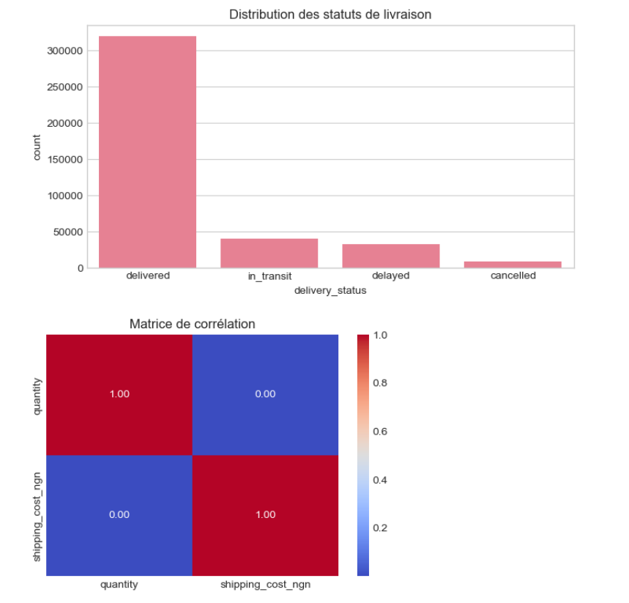
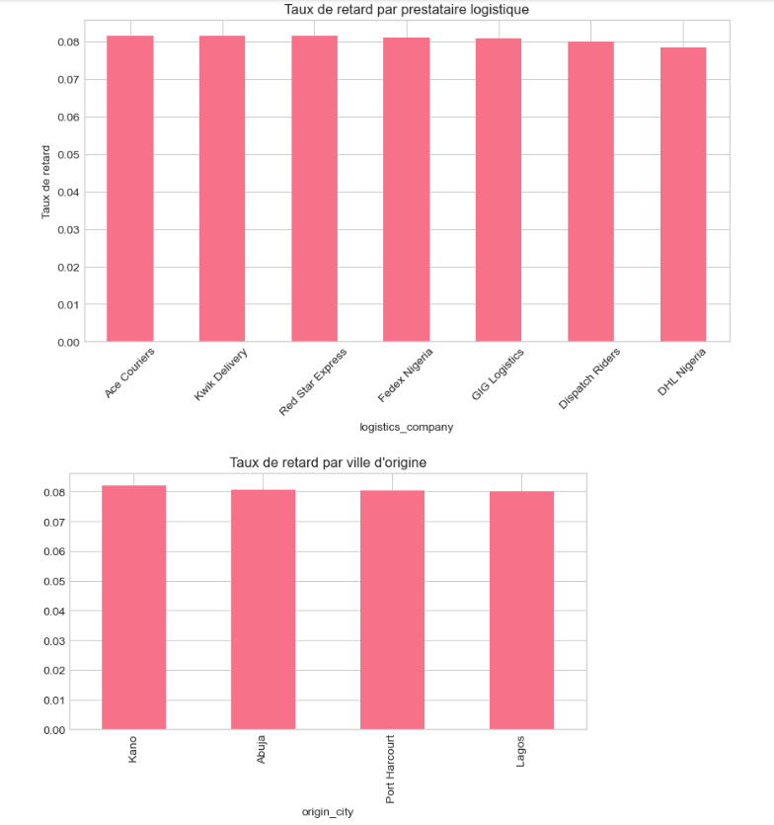
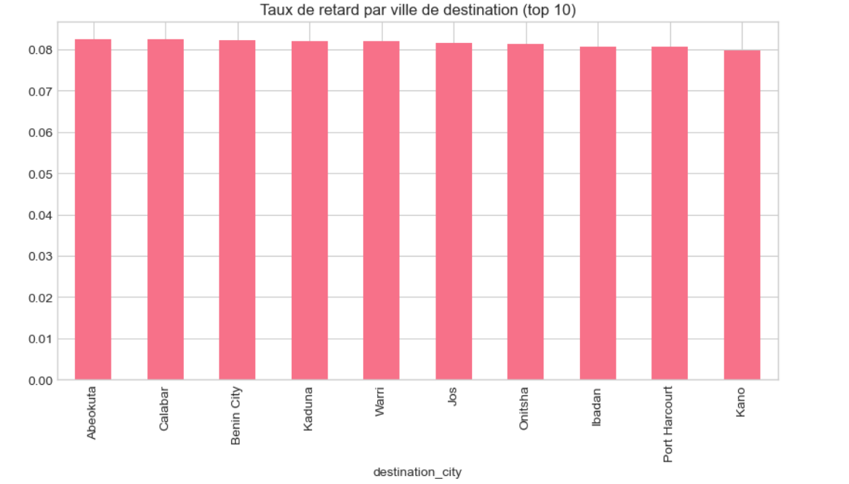
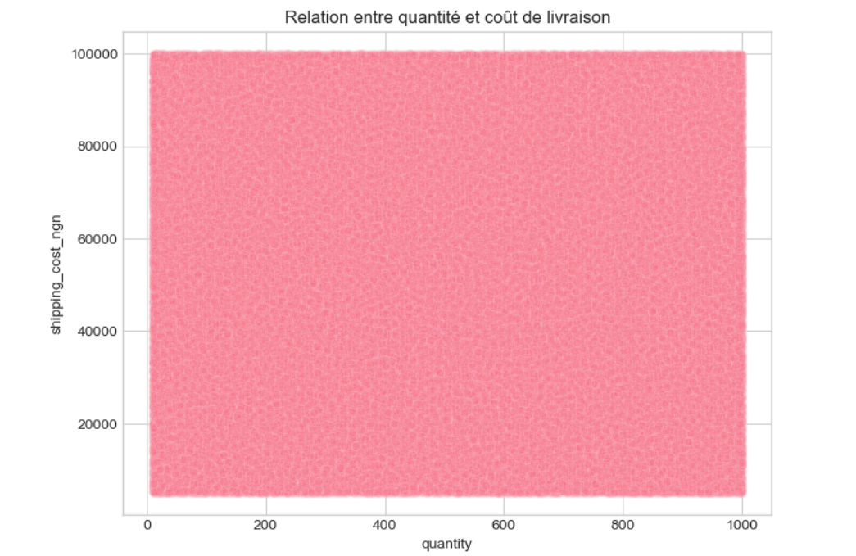

Colonnes supprimées : ['shipment_id', 'product_id']
Valeurs manquantes détectées :
delay_days 48130
dtype: int64

=== Détection des outliers (IQR) ===
quantity : 0 outliers (0.00%)
shipping_cost_ngn : 0 outliers (0.00%)

=== Transformations pour réduire l'asymétrie ===
Asymétrie initiale de shipping_cost_ngn : -0.003
Asymétrie après log : -0.995
Asymétrie initiale de quantity : 0.000
Asymétrie après log : -1.407

=== Aperçu après nettoyage ===
supplier_name origin_city destination_city ship_date \
0 Supplier_B Abuja Warri 2024-03-23
1 Supplier_D Kano Jos 2024-06-10
2 Supplier_E Lagos Port Harcourt 2024-10-15
3 Supplier_D Lagos Ibadan 2024-02-05
4 Supplier_D Lagos Enugu 2024-03-31

expected_delivery_date actual_delivery_date quantity shipping_cost_ngn \
0 2024-03-29 2024-03-27 828 18379.93
1 2024-06-21 2024-06-20 329 91632.07
2 2024-10-19 2024-10-18 203 77141.08
3 2024-02-19 2024-02-24 20 69484.82
4 2024-04-09 2024-04-14 465 47054.82

logistics_company delivery_status is_delayed delay_days \
0 DHL Nigeria delayed 1 -2.0
1 Fedex Nigeria delivered 0 -1.0
2 Ace Couriers delivered 0 -1.0
3 Kwik Delivery in_transit 0 NaN
4 Kwik Delivery delivered 0 5.0

log_shipping_cost log_quantity supplier_name_enc origin_city_enc \
0 9.819069 6.720220 1 0
1 11.425548 5.799093 3 1
2 11.253404 5.318120 4 2
3 11.148878 3.044522 3 2
4 10.759090 6.144186 3 2

destination_city_enc logistics_company_enc
0 14 1
1 8 3
2 13 0
3 6 5
4 5 5
<class 'pandas.core.frame.DataFrame'>
RangeIndex: 400000 entries, 0 to 399999
Data columns (total 18 columns):
# Column Non-Null Count Dtype
--- ------ -------------- -----
0 supplier_name 400000 non-null object
1 origin_city 400000 non-null object
2 destination_city 400000 non-null object
3 ship_date 400000 non-null datetime64[ns]
4 expected_delivery_date 400000 non-null datetime64[ns]
5 actual_delivery_date 400000 non-null datetime64[ns]
6 quantity 400000 non-null int64
7 shipping_cost_ngn 400000 non-null float64
8 logistics_company 400000 non-null object
9 delivery_status 400000 non-null object
10 is_delayed 400000 non-null int32
11 delay_days 351870 non-null float64
12 log_shipping_cost 400000 non-null float64
13 log_quantity 400000 non-null float64
14 supplier_name_enc 400000 non-null int32
15 origin_city_enc 400000 non-null int32
16 destination_city_enc 400000 non-null int32
17 logistics_company_enc 400000 non-null int32
dtypes: datetime64[ns](3), float64(4), int32(5), int64(1), object(5)
memory usage: 47.3+ MB
None
ship_date expected_delivery_date \
count 400000 400000
mean 2024-05-30 04:19:53.040000 2024-06-06 16:27:55.583999488
min 2024-01-01 00:00:00 2024-01-02 00:00:00
25% 2024-03-16 00:00:00 2024-03-24 00:00:00
50% 2024-05-30 00:00:00 2024-06-07 00:00:00
75% 2024-08-13 00:00:00 2024-08-21 00:00:00
max 2024-10-27 00:00:00 2024-11-10 00:00:00
std NaN NaN

actual_delivery_date quantity shipping_cost_ngn \
count 400000 400000.000000 400000.000000
mean 2024-06-08 04:27:16.055999488 504.906617 52547.524651
min 2023-12-31 00:00:00 10.000000 5000.290000
25% 2024-03-25 00:00:00 257.000000 28810.150000
50% 2024-06-08 00:00:00 505.000000 52634.390000
75% 2024-08-22 00:00:00 753.000000 76271.502500
max 2024-11-15 00:00:00 1000.000000 99999.530000
std NaN 286.132913 27410.200740

is_delayed delay_days log_shipping_cost log_quantity \
count 400000.000000 351870.000000 400000.000000 400000.000000
mean 0.080732 1.499594 10.672004 5.957052
min 0.000000 -2.000000 8.517451 2.397895
25% 0.000000 -1.000000 10.268518 5.552960
50% 0.000000 1.000000 10.871144 6.226537
75% 0.000000 4.000000 11.242068 6.625392
max 1.000000 5.000000 11.512931 6.908755
std 0.272424 2.292957 0.708278 0.882421

supplier_name_enc origin_city_enc destination_city_enc \
count 400000.000000 400000.000000 400000.000000
mean 2.000542 1.500063 7.000097
min 0.000000 0.000000 0.000000
25% 1.000000 0.000000 3.000000
50% 2.000000 2.000000 7.000000
75% 3.000000 2.000000 11.000000
max 4.000000 3.000000 14.000000
std 1.413857 1.118246 4.325335

logistics_company_enc
count 400000.000000
mean 3.000335
min 0.000000
25% 1.000000
50% 3.000000
75% 5.000000
max 6.000000
std 2.001569

Données nettoyées sauvegardées dans 'supply_chain_cleaned.csv'

